Story 01 - Book Overview - v2

Changes with respect to v1: see Technical Requirements

## Description

As a user

I want to see the overview of books

So that I can see which books are in the library

## Wireframe

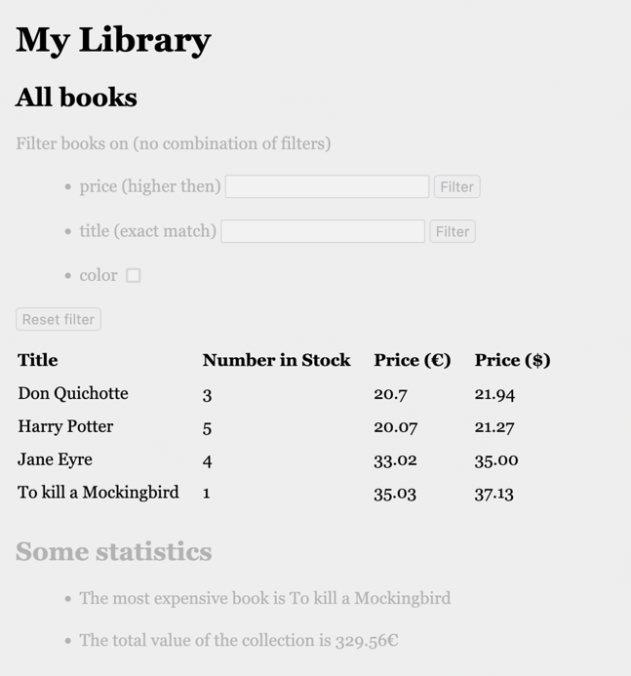

## Acceptance Criteria

* For each book, title, number in stock and price in euro and price in dollar are shown in table overview.

**API**

|  |  |
| --- | --- |
| **View all books of the library** | |
| **Request** | GET |
| **URL** | <http://localhost:8080/api/book/all> |
| **Input** |  |
| **Output: Happy Case** | JSON list of books |
| **Output: Unhappy Case** | Empty list when there are no books in the library |
| **Acceptance Criteria** | Returns all books in the library |

## Technical Requirements

* The response is a JSON array of books with fields “title” (String), “numberInStock” (int), “price” (double), “inColor” (Boolean), “priceInDollar” (double).
  + Hint: create for each required field in the response a so-called getter-method in the class Book. E.g. the method “getPriceInDollar()” causes the field “priceInDollar” to be created.
* Use the conversion ratio €1 = $1.06.
* In the given collection (library), the book title is unique.
* The books are stored in a h2 database.